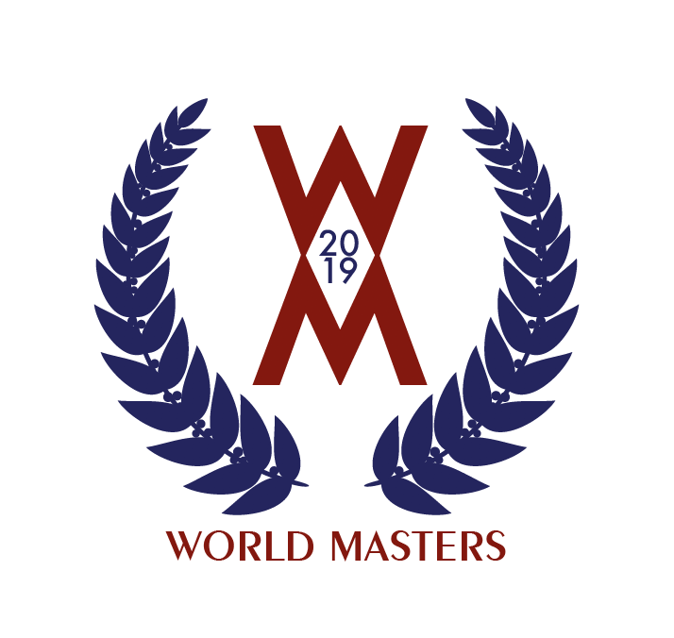

The USCTA is pleased to announce that entries are now open for all individual and team events comprising the 2019 World Masters Amateur Championships, to be held May 11-24, 2019. Please visit https://uscourttennis.org/2019worldmasters/ for full information on the Championships, and to submit your entry and make payment.

Entries close on March 31, 2019. After that date, additional entries will only be accepted off the waiting lists or to fill out draws, within our venues’ limits of court availability.

We look forward to your participation in the 2019 World Masters!

If you have any questions, please contact Steve Hufford, Tournament Organizer, at worldmasters2019@gmail.com or 703-244-6574.

