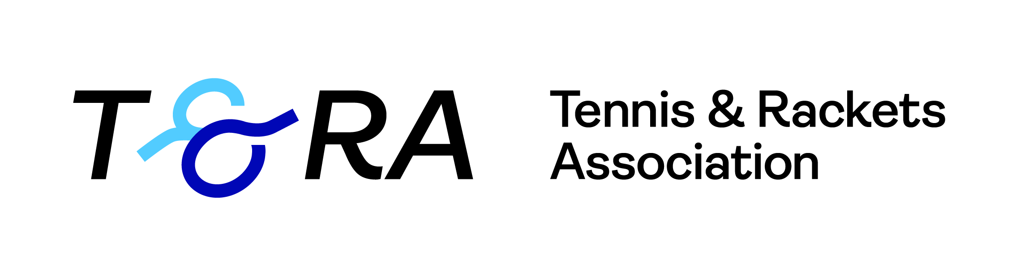

Rackets Invitation Singles Tournament
27th Nov – 5th Dec 2021, The Queen’s Club
Sponsored by the T&RA

Group A | 1 | 2 | 3 | 4 | Matches | Games | Position
- B Cawston |  | 0 | 3 | 3 | 2 | 6 | 2
- R Owen | 2 |  | 3 | 3 | 3 | 8 | 1
- M Farmiloe | 0 | 0 |  |  | 0 | 0 | 3=
- M Brooks | 0 | 0 |  |  | 0 | 0 | 3=

Group B | 1 | 2 | 3 | 4 | Matches | Games | Position
- A Duncliffe-Vines |  | 3 | 3 | 3 | 3 | 9 | 1
- B Bomford | 0 |  | 0 | 3 | 1 | 3 | 3
- N James | 0 | 3 |  | 3 | 2 | 6 | 2
- W Annetts | 2 | 0 | 0 |  | 0 | 2 | 4

Semi-finals  Saturday 4th Dec | Final  Sunday 5th Dec | Winner
R Owen
11:30 | R Owen
 | 15/10 14/16 15/3 11/15 15/6
N James
 | 14:00 | B Cawston
 |  | 5/15 15/9 15/2 15/0
B Cawston
14:30 | B Cawston
 | 15/10 15/9 15/7
A Duncliffe-Vines

Order of Play and Results
for Group Matches

Sat 27th Nov |  |  |  | Result | Marker/Ref
15:00 | A DV | bt | N James | 15/3 15/4 15/7 | HRA
18:00 | B Cawston | bt | M Farmiloe | 15/3 15/3 15/5 | HRA
Sunday 28th Nov
11:30 | B Cawston | bt | M Brooks | 15/0 15/9 15/4 | ST
13:00 | A DV | bt | B Bomford | 15/3 15/6 15/10 | ST
14:30 | R Owen | bt | M Farmiloe | 15/4 17/16 15/10 | ST
Mon 29th Nov
17:45 | R Owen | bt | M Brooks | 15/4 15/5 15/2 | HRA
20:30 | B Bomford | bt | W Annetts | 15/2 15/3 15/1 | HRA
Tue 30th Nov
18:30 | N James | bt | B Bomford | 15/12 15/1 18/16 | HRA
20:00 | A DV | bt | W Annetts | 15/5 14/16 15/11 14/15 15/4 | HRA
Thurs 2nd Dec
18:00 | R Owen | bt | B Cawston | 15/8 15/7 retired | ST
19:15 | N James | bt | W Annetts | 17/16 15/5 15/2 | ST
20:30 | M Farmiloe | vs | M Brooks |  | ST

All matches will be best of five games
- All matches to be played on the Championship Court
- The top two players of each group will progress to the semi-final

