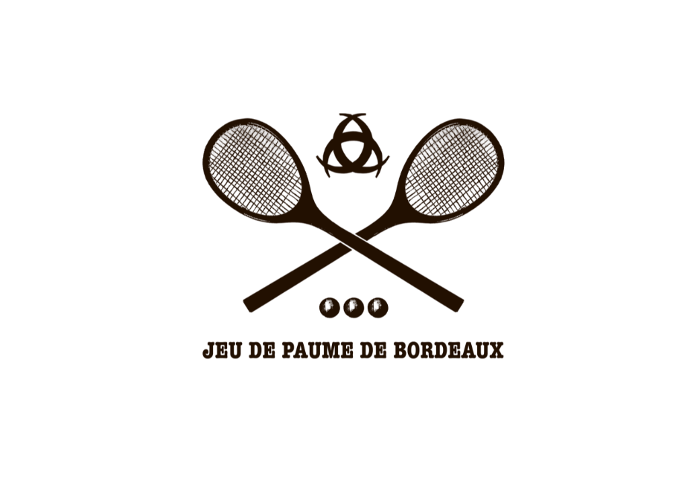

WORLD CHAMPIONSHIP HANDICAP DOUBLES

Gentlemen & Ladies Amateur Handicap Doubles
International Tournament

To be held at

Jeu de Paume de Bordeaux

From

29th June to 3rd July 2022

ENTRIES MUST BE RECEIVED BY NO LATER THAN 12th June 2022

ENTRIES WILL BE LIMITED TO 20 PAIRS IN THE DOUBLES
ON A FIRST COME, FIRST SERVED BASIS. TOP 10 PAIRS WILL COMPETE IN AN A DIVISION SPLIT IN TO TWO GROUPS. THE REMAINING 10 PAIRS WILL COMPETE IN A B DIVISION SPLIT IN TO 2 GROUPS.
*MUST BE READY TO PLAY FROM WEDNESDAY 29TH 10AM

Entry fee includes :
*All matches marked
*Tournament gift
* welcome cocktail drinks
* standing ticket to all WDC matches (non transferable)
*prizes for winners & finalists

CONTACT
Head Professional- Nick Howell
Jeu de Paume de Bordeaux Domaine de Rocquevielle, 107 Avenue Marcel Dassault, 33 700 Mérignac Par mail : pro@jeudepaumebordeaux.com +33 9 73 17 74 41

ENTRY FORM

Name/First Name : …………………………………………………………………………………………… Address : ……………………………………………………………………………………………………………
…………………………………………………………PostCode City: …..…………………………………..
Telephone and/or Mobile phone : …………………………………………………………………….
Email : ………………………………………………………………………………………………………………..
Handicap : …………………………………… Club : ……….………….………………………..
Email : …………………………………………………………….…………………………………………………..

Date : …………………………………… Signature : …………………….…………………………………..
Please fill in the competition you wish to play in :

Doubles : 110 €
Name and handicap of your doubles partner : ………………………………………………………
(Please contact us if you would like to play in the doubles but do not have a partner yet)

Completed forms should be returned to :
pro@jeudepaumebordeaux.com

