Manchester Gold Racquet 2022
Sponsored by QBS Software
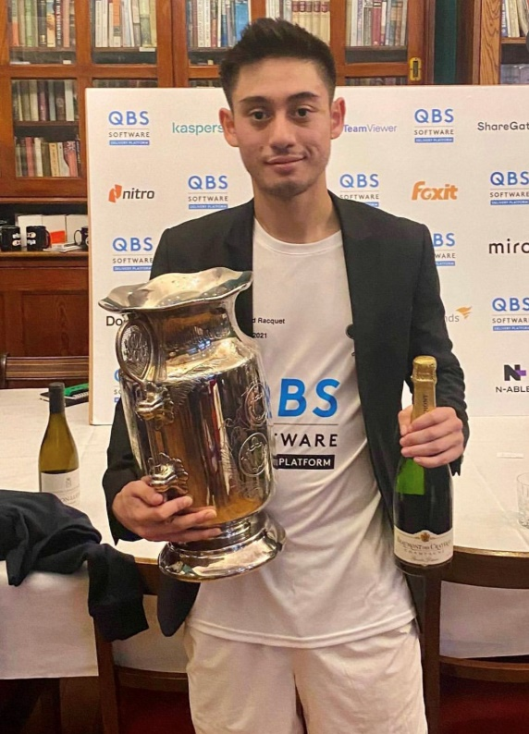

Ben Cawston with the Manchester Gold Racquet Trophy in 2021
Entries are invited for the Manchester Gold Racquet which will be held at the Manchester Tennis and Racquet Club between Friday 28th October and Sunday 30th October 2022.
Rackets:
There will be both a Singles tournament for the Manchester Gold Racquet and a Doubles tournament. The current holder of the Singles title is Ben Cawston; and Ben Cawston & Alex Duncliffe-Vines are the holders of the Doubles title. There will be a Doubles and a Singles Plate competition for the first-round losers. The tournament is open to both amateurs and professionals. The Singles tournament is not a World Championship Qualifying tournament but the Doubles is a Tier 2 World Championship Qualifying Tournament.

Thanks to our sponsor, QBS Software, all players will receive a tournament playing shirt included in their entry fee. Social Media coverage and photography will also be in operation throughout the event.

In contrast to previous editions of the tournament, an order of play with match timings will be produced to avoid both the situation of players having to play multiple matches in quick succession and to avoid exceedingly late timings of matches. Every endeavour will be made to ensure that the order of play does not impose excessive scheduling demands on the top-ranking players who may wish to enter both the Singles and the Doubles.

It is nonetheless hoped that many “club” standard players will enter the tournament in addition to the top-ranking competitors, though they may be asked to play one or more preliminary round matches on the Thursday or on the Friday morning, before the competition proper. It is anticipated that every competitor will have the opportunity to play a minimum of three rackets matches.

Tennis:
The Tennis Court will be reserved for Gold Racquet competitors on Saturday 29th October. On Sunday the Tennis Court is in use for the MTRC Family Tournament.
Tournament Dinner:
There will be a Champagne Reception & Black Tie Dinner at the Club on the evening of Saturday 29th October, the price of which is included in the entry fee. Partners and guests are welcome to attend the Dinner at £40.00 per person. There will be plans to book tables at a bar in Manchester immediately after the tournament dinner.

Accommodation:

Information about local hotels will be made available on request; and some accommodation may be provided by members if required. If you would like to be hosted with a member, please contact the tournament organiser as soon as possible. We will try and host as many entrants as possible. Please note that Manchester United are playing at home to West Ham on Sunday 30th October which may affect the availability of certain hotels.

Entry Fees:

The entry fee for amateur players is £150 (Reduced to £50 for those who commit to play each game in the official QBS Sponsored shirt). This will cover the Tournament itself, the Tournament Dinner and sandwiches/soup for lunch on Saturday and Sunday. Players can request Sunday lunch at an additional cost of £15.00. There will be no entry fee for professional players who will also be provided with lunch/dinner at the Club without charge. Reasonable expenses will be paid to professionals based in the United Kingdom; and the Club will consider on an individual basis whether to reimburse all or part of any expenses incurred by professionals based overseas. Professionals should contact the tournament organiser in advance of the event with their specific requirements.

Entry Forms:
Entry forms should be completed and returned to the organiser Robert Shenkman (robboshenk@hotmail.com) no later than Friday 21st October 2022. Later entries will be accepted only at the discretion of the Organiser. Any postal communications should be addressed to the Manchester Tennis & Racquet Club, 33 Blackfriars Road, Salford, United Kingdom, M3 7AQ (Tel: 0161 834 0616). Any further questions can be directed to the tournament organiser via email or other relevant method via social media.
Payment:
It is a condition of entry that payment of the entry fee must be made before the start of the Tournament.

Entry Form
I wish to enter the Manchester Gold Racquet Tournament 2022:-
Name:-

Address:-

Telephone Number (mobile and land-line):-

Email:-

Status (Amateur or Professional):-

Shirt size:

Additional Tournament Dinner Ticket (if required):-

My partner in the Doubles will be (if none chosen, a partner will be allocated):-

Expected Time of Arrival and scheduling requests (important for the production of the order of play and match timings):-

If possible, I would like accommodation with a member (stating the number of persons for whom accommodation is required):-
I enclose a cheque for the entry fee or I will pay by Bacs to the Club. Please indicate which.
(Sort code 08-92-99 Ac no 65821431 using your name as reference)

