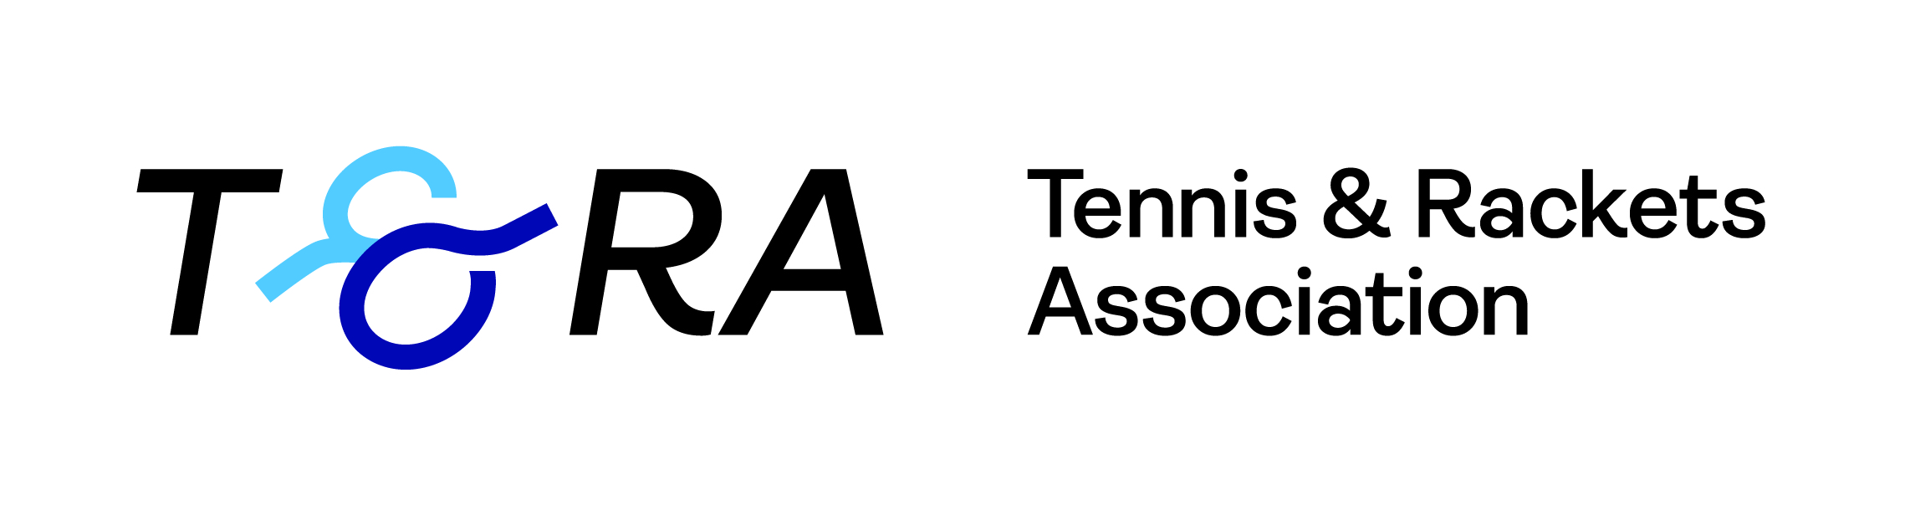

Rackets Invitation Singles Tournament
2nd – 11th December 2022, The Queen’s Club
Sponsored by the T&RA

Group A | 1 | 2 | 3 | 4 | Matches | Games | Position
- Ben Cawston |  | 3 | 3 | 3 | 3 | 9 | 1
- Rory Giddins | 0 |  | 3 | 3 | 2 | 6 | 2
- Julius Manton-Jones | 0 | 1 |  | 3 | 1 | 4 | 3
- Ed Hyde | 0 | 0 | 0 |  | 0 | 0 | 4

Group B | 1 | 2 | 3 | 4 | Matches | Games | Position
- Alex Titchener-Barrett |  | 3 | 3 | 3 | 3 | 9 | 1
- James Coyne | 0 |  | 0 | 0 | 0 | 0 | 4
- Will Annetts | 0 | 3 |  | 3 | 2 | 6 | 2
- Alastair Gourlay | 0 | 3 | 0 |  | 1 | 3 | 3

Semi-finals  Saturday 10th Dec | Final  Sunday 11th Dec  Sunday 28 November | Winner
Ben Cawston
Winner Group A
14:30 | Ben Cawston
 | 15/1 15/5 15/0
Will Annetts
Runner-Up Group B
 | 14:00
Rory Giddins
Runner-Up Group A
11:30 | Alex Titchener-Barrett
 | 15/4 15/3 15/3
Alex Titchener-Barrett
Winner Group B

Order of Play
for Group Matches

Friday 2nd Dec |  |  |  | Result | Marker/Ref
18:30 | A Titchener-Barrett | bt | A Gourlay | 15/4 15/7 15/2 | ST
19:30 | B Cawston | bt | R Giddins | 15/6 15/3 15/3 | ST
Saturday 3rd Dec
13:30 | B Cawston | bt | J Manton-Jones | 18/13 15/0 15/1 | HRA
14:45 | A Titchener-Barrett | bt | W Annetts | 15/4 15/7 15/2 | HRA
Sunday 4th Dec
14:45 | R Giddins | bt | E Hyde | 15/9 15/9 15/1 | ST
16:00 | W Annetts | bt | J Coyne | 15/11 15/11 15/8 | ST
Monday 5th Dec
18:00 | J Manton-Jones | bt | E Hyde | 15/12 15/6 15/4 | BC
Tuesday 6th Dec
17:00 | W Annetts | bt | A Gourlay | 15/2 15/8 15/4 | BC
18:30 | A Titchener-Barrett | bt | J Coyne | w/o | ST
19:45 | J Manton-Jones | bt | R Giddins | 12/15 15/1 15/2 15/4 | ST
Thursday 8th Dec
18:30 | A Gourlay | bt | J Coyne | w/o | ST
19:45 | B Cawston | vs | E Hyde | 15/2 15/6 15/1 | ST

All matches will be best of five games
- All matches to be played on the Championship Court
- The top two players of each group will progress to the semi-final

