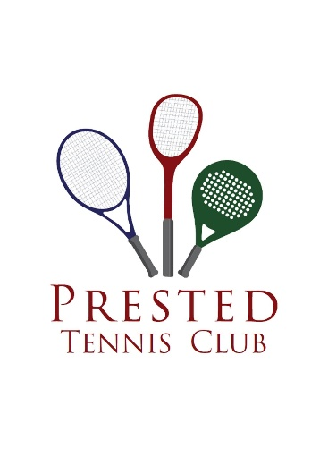
3

The Prested Hall of Fame
Open Handicap Doubles Championships
Prested Tennis Club

Saturday 13th & Sunday 14th May 2023
Including reception drinks and 3-course dinner in the Club Bistro on Saturday night *

Current Title Holders: Chris Wilson & Paul Dickson

The format is dependent on the number of entries but will include round robin groups and a plate competition for those defeated in early rounds.

ENTRY FORM
PLEASE TICK
£35 per player Tournament only
£70 per player Tournament & Dinner

NAME: |  | EMAIL:
HOME TELEPHONE: |  | MOBILE:
REGISTERED CLUB: |  | HANDICAP:
PARTNER:
SIGNED: |  | DATED:

Please make a bank transfer to ‘Mark Hobbs’ by Friday 5th May 2023
Mark Hobbs Sort Code: 20-60-38 Account number: 13883086

For any queries please contact: Prested Tennis Club, Prested Hall Chase, Feering, Kelvedon, Essex CO5 9EE
Tel: 01376 570220 / Email: bookings@prestedtennisclub.co.uk

