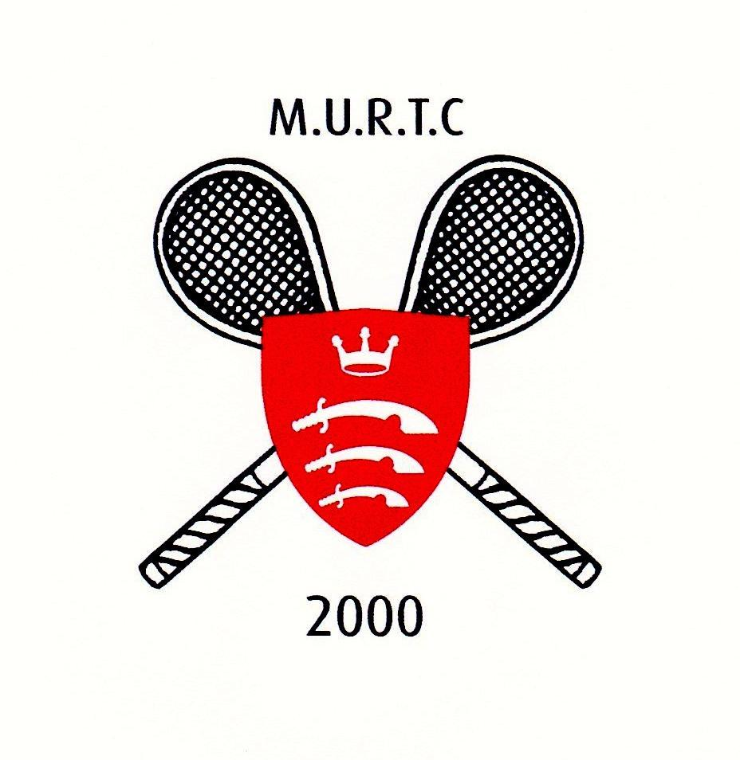

THE CATTERMULL CUP

SCHOOLS’ ALUMNI* DOUBLES HANDICAP CHAMPIONSHIP

(Holders: Winchester)
To be held at MURTC (Middlesex University, Hendon)
0n 14th to 16th October 2022
School (and Pair Number if applicable)
Player 1 | Club : | Handicap :
Player 2 : | Club : | Handicap :
Contact Numbers
Emails
I can confirm that all entrants are members of the T&RA
* Each pair must be formed by old pupils who attended the same school.
The tournament will use the familiar group system to ensure pairs participate in at least three matches. All participants should check with their school coordinator to organise their team. We will be accepting 1 pair per school; however, a second pair will be considered depending on the number of entries.

Please email your form to pros@murtc.co.uk and pay your fees using the following details:
Bank Account Details:
Middlesex University Real Tennis Professionals
Account: 40153713 Sort Code: 23-05-80
£70.00 per pair

The organisers will try to accommodate timing requests wherever possible. Please indicate preferences:

Friday 14th October | 12 - 3 pm | 3 - 6 pm | 6 - 9 pm
Saturday 15th October | 9am – 12pm | 12 - 3pm | 3 - 6 pm

Those playing on Friday would not be required on Saturday. If you are happy/keen to play on Friday, then please indicate above. All pairs will need to be available on Sunday 16th October for the Knockouts.

The Tournament Organisers are:
Will Burns (pros@murtc.co.uk) 0208 457 9568
Paul Cattermull (paul@duckfolly.co.uk) 07811 939048

CLOSING DATE for ENTRIES Sunday 25th September 2022
The draw will take place on Monday 26th September
No late entries will be accepted... without exception!
All players must be members of the T&RA and handicaps should be as listed in its website: www.realtennisonline.com

