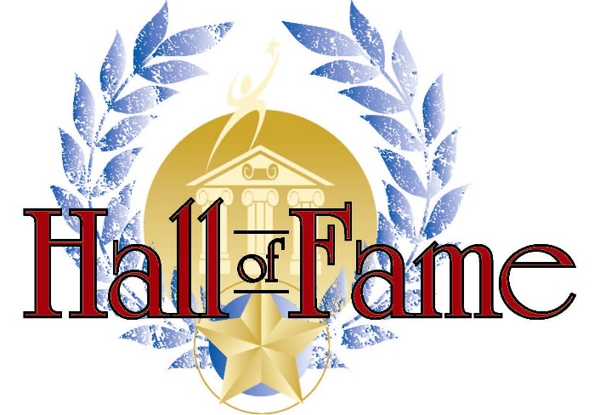
The Prested Hall of Fame
Open Handicap Doubles Championships

Saturday 13th & Sunday 14th May 2023
Including cold buffet lunch on both Saturday & Sunday plus reception drinks and 3-course dinner* in Prested Hall on Saturday evening

Current Title Holders: Chris Wilson & Paul Dickson

The format is dependent on the number of entries but will include round robin matches followed by a knockout and plate competitions. All pairs guaranteed at least 4 matches.
Open to members and non-members

ENTRY FORM | PLEASE TICK
£35 per player Tournament only
£70 per player Tournament & Dinner*
£35 per additional Dinner Guest

NAME: |  | EMAIL:
HOME TELEPHONE: |  | MOBILE:
REGISTERED CLUB: |  | HANDICAP:
PARTNER:
SIGNED: |  | DATED:

Please make a bank transfer to “Ian Hawkey” by Saturday 6th May 2023
Bank Sort Code: 04-00-75 Account number: 86590782
(if you could add a Reference : “PRTC HoF”)

For any queries please contact: Ian Hawkey, Prested Tennis Club, Feering, Kelvedon, Essex CO5 9EE
Tel: Ian Hawkey 07768 462427 / Email: ihawkeyuk.prtc@gmail.com

