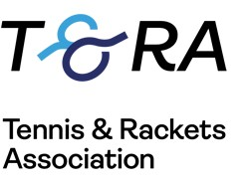

The British Over 50 Amateur Doubles Championships
Prested Tennis Club

Saturday 2nd October to Sunday 3rd October 2021
Entry Form

Format is dependent on entries, but there will be round robin groups and a plate competition for those who are defeated in the early rounds.

Please make a bank transfer of £35.00 (per player) to ‘Mark Hobbs’ by Monday September 27th
Mark Hobbs Sort code: 20-60-38 Account number: 13883086
Prested Hall, Feering, Kelvedon, Essex CO5 9EE
Tel: 01376 570220 Email: mark@prestedtennisclub.co.uk

All entrants in the tournament must be members of the T&RA.
To apply for Membership, contact the T&RA on 0207 835 6957 or please use the following link to sign up online www.tennisandrackets.com/about/join

Name. ______________________________________________________

Telephone. __________________ Mobile. ___________________

Email. ______________________ Handicap. _________________

Date of Birth. ________________ Club. _____________________

Partner. _____________________
(Must be over 40 by 02/10/2021)

Signed. ______________________ Date. _____________________

